DYPIU
Subject: Block Chain Systems Batch: CC1
Name: Shweta shelke
PRN: 20220802278
Lab2

Objective:
Simulate a Bitcoin transaction using a blockchain explorer API. Track the transaction from initiation to confirmation.

Prerequisites:
- Online RemixIDE
- Basic Knowledge on Block Chain Work<low Code:
Storage Contract
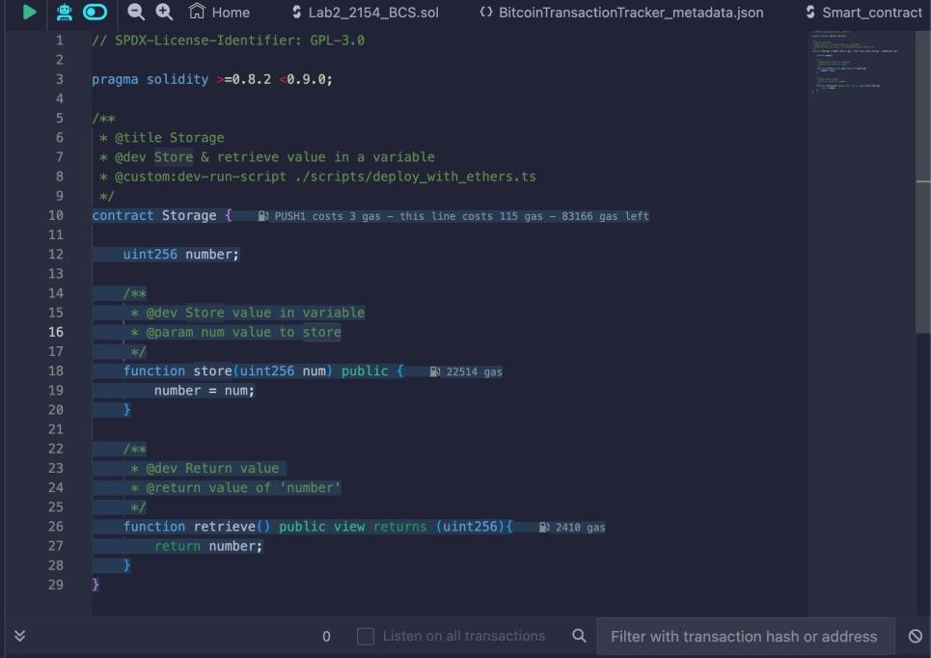

- Compile and Run the File

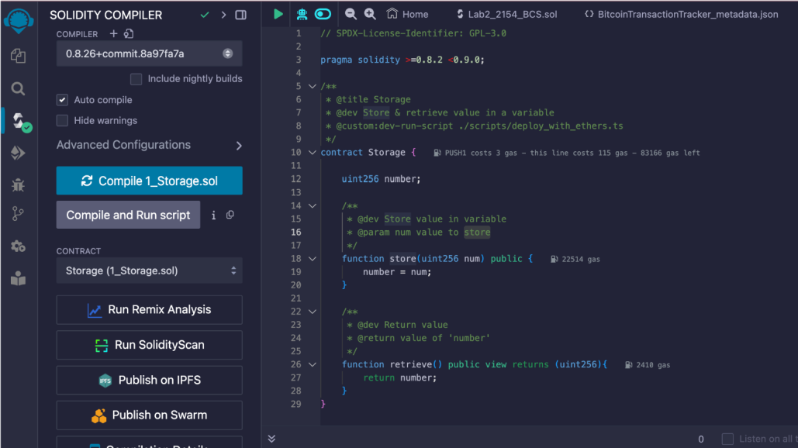

- Click | on Deploy below Solidity | Compiler | → | Click | on
 | “Deploy” → Enter store | value and | then | click | on
 | retrieve
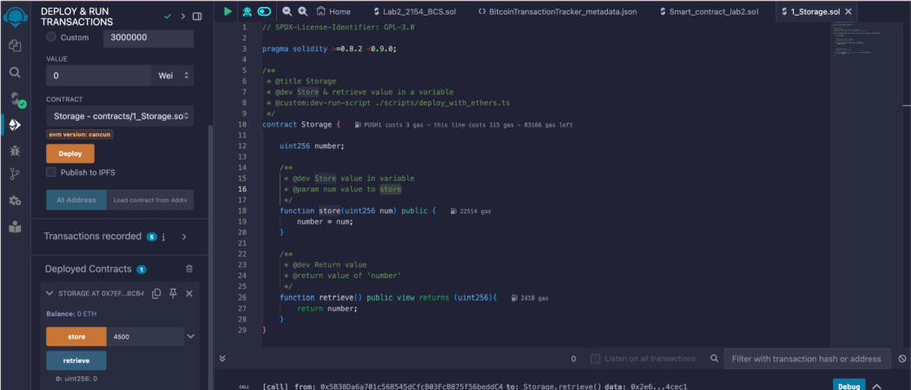

Terminal Output:

You can see the transaction details in the terminal
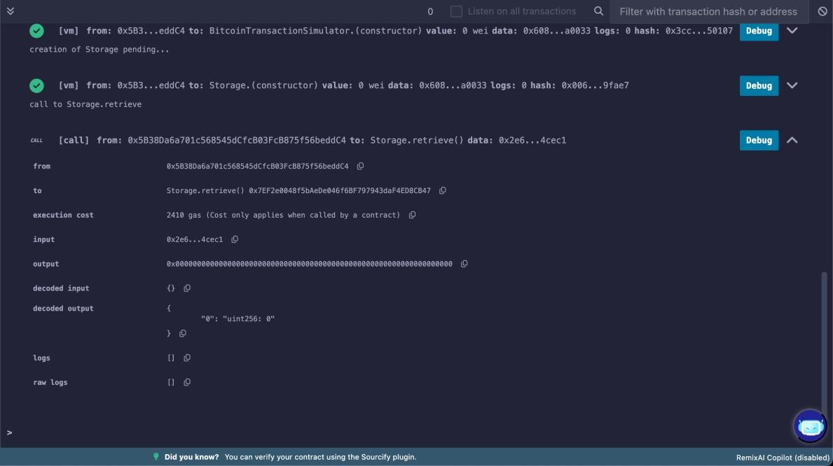

Conclusion:

In | conclusion, the |  | simulation | of | a Bitcoin | transaction
using | a blockchain |  | explorer | API | provided | valuable insights
into | the blockchain |  | workflow. | By | tracking | the transaction
from initiation to confirmation, we were able to observe
the | various | stages and processes |  |  | involved. This |  | exercise | not
only | enhanced | our understanding |  |  | of blockchain |  | technology | but
also demonstrated the practical application of blockchain in real-world scenarios. The successful completion of this lab
underscores the importance of blockchain in ensuring secure and transparent transactions in the digital age.

